Name: _________________________

Navigation and the North Star Student Activity Pack

Comprehension Questions:
(1) What were some dangers that sailors faced?

(2) Why did some sailors hug the coastline?

(3) Why was hugging the coastline not a good strategy?

(4) What did sailors need to know to avoid getting lost?

(5) What two methods could sailors use to determine their direction?

(6) What was the disadvantage of using a compass to determine direction?

(7) What was the disadvantage of using the North Star to determine direction?

(8) How does the North Star move during the night?

(9) How do other stars move during the night?

(10) How could sailors figure out their latitude by looking at the North Star?

(11) What tool did sailors use to measure the angle of elevation of stars or the sun?

(12) How do modern sailors find their locations?

(13) What do you need to determine your longitude?

(14) What famous scientists worked on the problem of determining longitude?

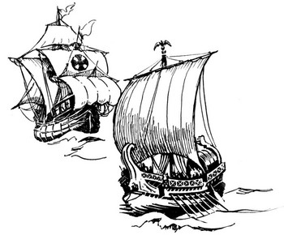

© 2004 www.science-teachers.com

Latitude and the North Star

Refresh Your Memory: What is the latitude on the map of the following locations:
The North Pole |  | The Tropic of Cancer
The Equator |  | The Arctic Circle
London, England |  | Washington, USA
Helsinki, Finland |  | Ottawa, Canada

Look at the diagrams below. Using a protractor, measure the angle of the North Star relative to the horizon and write down the latitude of the ship.

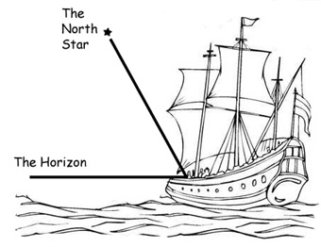 |  | 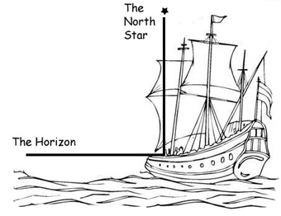
(1) Latitude: ______________________ |  | (2) Latitude: ______________________
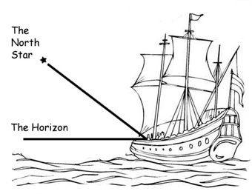 |  | 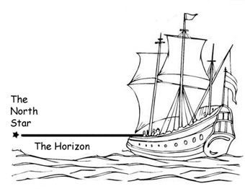
(3) Latitude: ______________________ |  | (4) Latitude: ______________________
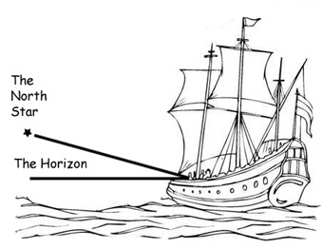 |  | What does it mean if the North Star sinks below the horizon?  _________________________________  _________________________________  Next time you go on vacation, try to determine your latitude by locating the North Star.
(5) Latitude: ______________________
© 2004 www.science-teachers.com

Navigation by the North Star Crossword

Across  3 The name of the North Star. (7)  5 The 'M' constellation. (10)  10 The star that sailors used to determine their latitude. (5,4)  12 The skill of finding your location and direction. (10)  - 90 degrees latitude. (5,4)  - 0 degrees latitude. (7)  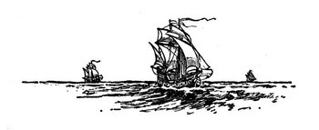 |  | Down  1 A tool that determines which direction is north. (7)  2 Another word for sailor. (7)  4 A flat line as far as the eye can see. (7)  6 What the earth spins on. (4)  7 A tool sailors used to measure angles. (7)  8 cloudy. (8)  - Constellation used to locate the North Star. (3,6)  11 The number of stars in the  Big Dipper. (5)
www.science-teachers.com

