
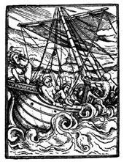  Wood Cut by Hans Holbein |  | Navigation by the North Star: Finding Your Latitude and Direction.  Sailors have always faced great risks when they travelled at sea. Sudden storms could break their masts and shred their sails. Giant waves could sink their ships or wash men overboard. Hidden reefs could tear open their hulls. And even if they were lucky enough to avoid these, sailors could still become hopelessly lost and wander until starvation, thirst or disease set in.  There was nothing they could do about the weather, but, with proper navigation, sailors could avoid hidden reefs and keep from getting lost. One strategy that early mariners used to avoid getting lost
was to stay close to the coast. If they hugged the coast, they could get their bearings from recognizable landmarks such as mountains, rivers, and islands.

The problem with this form of navigating was that it limited the places where sailors could go. There were no landmarks on the open ocean. Also, if sailors strayed into unknown waters, they wouldn’t be able to recognize any of the landmarks even if there were some. And so, they needed more reliable methods to find their way.

Fortunately, there were things that could be seen from anywhere on the globe that could give sailors their bearings: the stars, the sun, and the earth’s magnetic field. But even these could only solve part of the puzzle. To avoid getting lost sailors needed to know two things: where they were and where they were going. To know where they were, they needed to know their latitude and longitude. To know where they were going, they needed to know their compass direction.
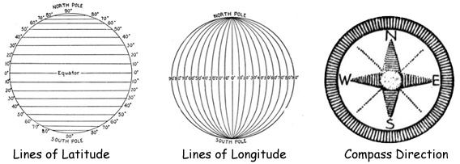
Things a Sailor Needed to Know to Avoid Getting Lost:
Latitude, Longitude, and Direction
To find their direction, sailors could use a compass or the stars. The needle of a compass points in a northern direction from almost anywhere on Earth. The North Star was also a reliable way to determine north. As it turns out, the North Star is located directly over the North Pole so wherever the North Star is in the sky, that direction is north.

Of the two methods for determining north, early navigators preferred using the stars because early compasses were unreliable. They sometimes lost their magnetic charge and became useless. Also, the ship’s motion made it difficult to get a steady reading from the compass. For centuries, many great scientists worked on the technical problem of keeping a compass needle steady. And then there was the problem of variation: a compass needle doesn’t point to true north, it points to magnetic north. As you sail around the globe, magnetic north changes in relation to true north. The North Star on the other hand was always located at true north. And as long as sailors could see it, they could get their bearing from it. But that was the problem: the North Star was hidden when the sky was overcast.

To figure out their location, sailors needed to know their latitude and longitude. Again, the stars and the sun could be used to solve part of the puzzle: latitude. Because the North Star is located directly over the North Pole, it appears fixed in the sky at night. All of the other stars appear to travel in circular arcs across the night sky (around the North Star). Sailors only had to measure the angle of elevation of the North Star and they could figure out their latitude on the map. It turns out that the angle of elevation of the North Star is equal to your latitude on the map. Measuring the angle of elevation was easy to do. Sailors used a tool called a sextant to measure the angle of the sun or the stars. Nowadays, ships use satellite signals to determine their location, but they still carry a compass on board and most captains still know how to take a reading of off the stars.

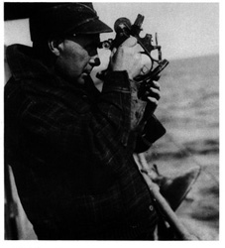  A fisherman using a sextant to navigate. |  |  |  | Longitude was a lot more difficult to determine accurately. To determine longitude, sailors needed a very precise clock. The clock could not run too fast or too slow. It also had to withstand the constant motion of the ship at sea. Newton, Galileo, and Hooke all worked on the problem of determining longitude, but it took many centuries before someone finally invented a clock that was accurate enough to be relied upon. But that is another story.  In this lesson you will:  (1) Make a sextant.  (2) Find the North Star.  (3) Measure your latitude on the map.

© 2004 www.science-teachers.com

