Measuring Your Latitude Using a Sextant
Figure 1.  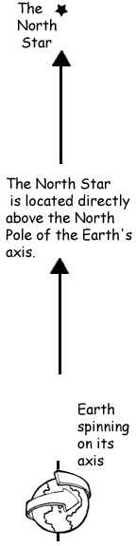  Figure1: The picture to the left shows the North Star is located directly over the Earth’s axis of spin. | Now that you’ve made a sextant, you can take that sextant and measure the angle of objects relative to the horizon. If you examine the diagrams below, you can see that measuring the angle of elevation of the North Star is the same as your latitude on the Earth. So, using your sextant and the stars, you can figure out your latitude on the map. To calculate your latitude use this formula:  Latitude =  90 Degrees – Protractor Angle  Figure 2: As you move from the equator to the North Pole, the angle of elevation of the North Star relative to the horizon changes. |  |  | 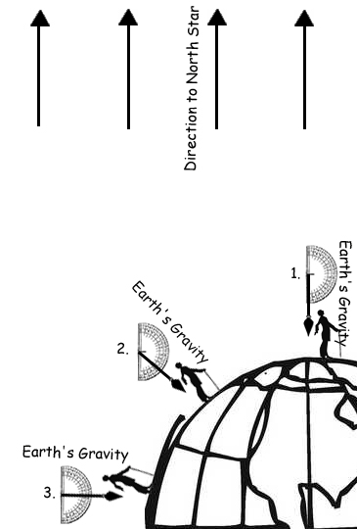  Figure 2
 | Figure 3
 |  | 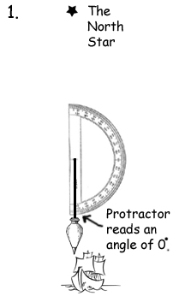 |  | 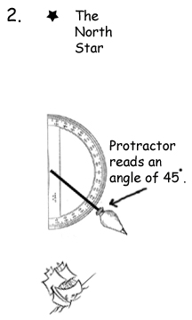 | 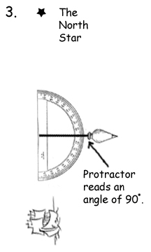
Homework: On the next clear night, try to find the North Star and measure your latitude according to your homemade sextant. |  | At the North Pole, your protractor should read 0 degrees. Your latitude is (90-0) degrees. |  | At 45 degrees latitude, your protractor should read 45 degrees. Your latitude is (90-45) degrees. | At the equator, your protractor should read 90 degrees. Your latitude is (90-90) degrees.
www.science-teachers.com

