Making a Crude Sextant Using Classroom Materials
In this class, you will make a crude sextant out of materials that you can easily find in any stationary store. Using your sextant, you can then take a measurement of the North Star and calculate your latitude.  Materials You Will Need:  Protractor  Straw.  Fishing line.  Weight.  Tape.  Paper |  | 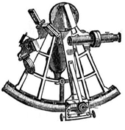  This is a sextant, a tool used by early navigators to measure the angles between stars. With this instrument, they were able to determine their latitude on the map.
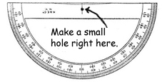 | Step 1: If your protractor doesn’t already have a hole in the center, make a small hole there.
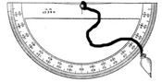  Figure A -The right way to tie the fishing line | Step 2: Tie a small fishing weight to a piece of fishing line and then tie the other end to the protractor. Make sure you tie it the way it is tied in figure A and not the way it is tied in figure B. If you tie it the way it is tied in figure B, your sextant will be inaccurate. It is also a good idea to cut a very tiny groove at the top of the protractor to fit the fishing line into.  Step 3: Turn the protractor upside down and tape a straw along the top. As an option you can add a paper eye guard to eliminate interfering light. Your finished product should look something like the picture below.
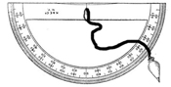
Figure B -The wrong way to tie the fishing line
The Finished Product: A Crude Sextant  To find the angle of elevation of any object, first locate the object in the straw. Next, stop the weight from swinging and press the taught fishing line to the protractor. The angle of elevation is the same as 90 degrees minus the angle you read off of the protractor. In this case the protractor reads 80 degrees so the angle of elevation is 10 degrees. |  |  | 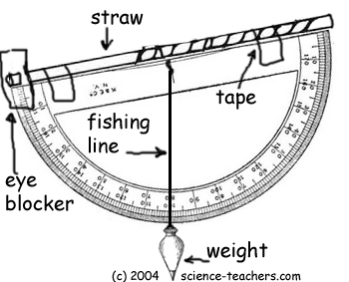

© 2004 www.science-teachers.com

