Finding the North Star |  | 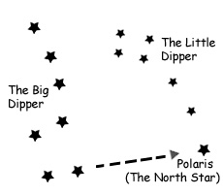  How to Find the North Star
If you want to use the North Star to navigate, the first thing you have to do is find it: First, locate the Big Dipper. Then using the two stars at the end of the spoon to make a straight line, follow the line until you come to a bright star. That is Polaris, the North Star. The North Star is also the last star on the handle of the little dipper.

Star Swirls

Throughout the night, stars appear to travel across the sky in circular arcs. This apparent motion is caused by the Earth spinning on its axis. Stars that appear close to the North Star travel in small circles. Stars that appear far from the North Pole travel in wide circles. Because the North Star is directly over the Earth’s axis of spin, it barely appears to move at all. If you take a picture of the night sky and leave the camera shutter open for a period of time, you can see star swirls that result from the apparent movement of stars across the sky.

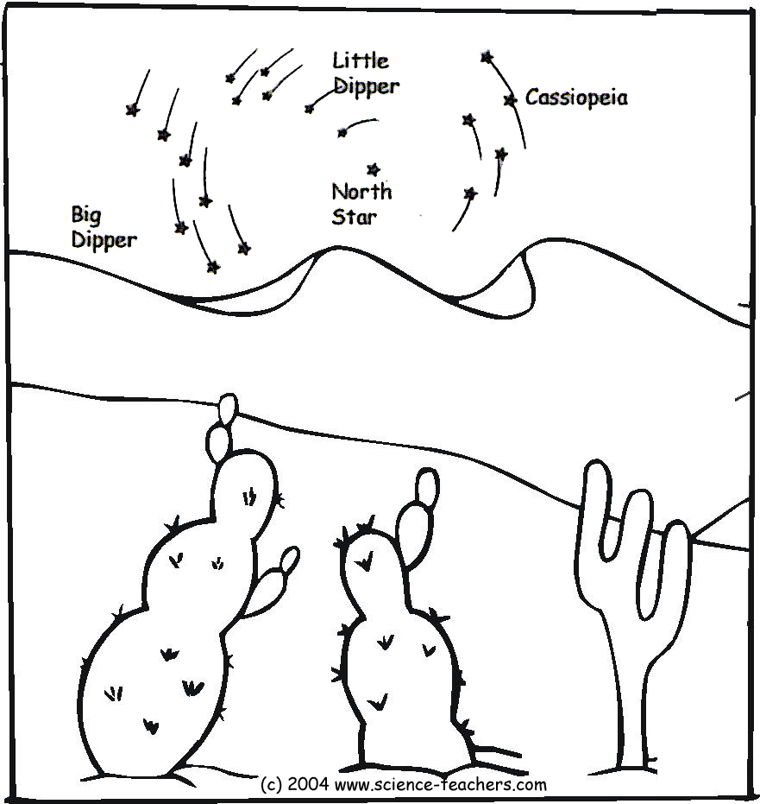 |  |  | This diagram shows the apparent movement of the stars across the night sky. Only the North Star, which is directly above the Earth’s axis, remains fixed. That is why the North Star is used to take absolute measurements of latitude.  The closer you get to the North Pole, the higher the swirl is in the sky. At the North pole, the center of the swirl is directly above you. As you go closer to the equator, the center of the swirl moves closer and closer to the horizon.
This is a picture of the night sky taken with the shutter left open for a period of time. The North Star is the bright star that you can see in the center of the photo.  (This photo has been sharpened using Photoshop to highlight the swirl effect) | 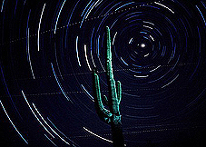
© 2004 www.science-teachers.com

