 |  |  | Name: __________________________  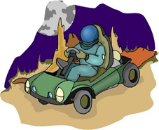  Across  3 The Dragon. (5)  4 The man who rescued Cepheus's daughter. (7)  6 The North Star. (7)  8 The Great Bear. (4,5)  10 The Queen sitting in her throne. (10)  11 A grouping of stars that is part of Ursa Major. (3,6)  12 The pole star in the age of the pharaohs. (6)  14 Cepheus's daughter. (9)
Down  1 The woman who became the great bear. (8)  2 A constellation near the North Star. (11)  5 The Little Bear. (4,5)  7 A group of stars. (13)  9 One of the pointer stars. (5)  10 Cassiopeia's husband. (7)  13 A star that orbits another star. (6) | 