
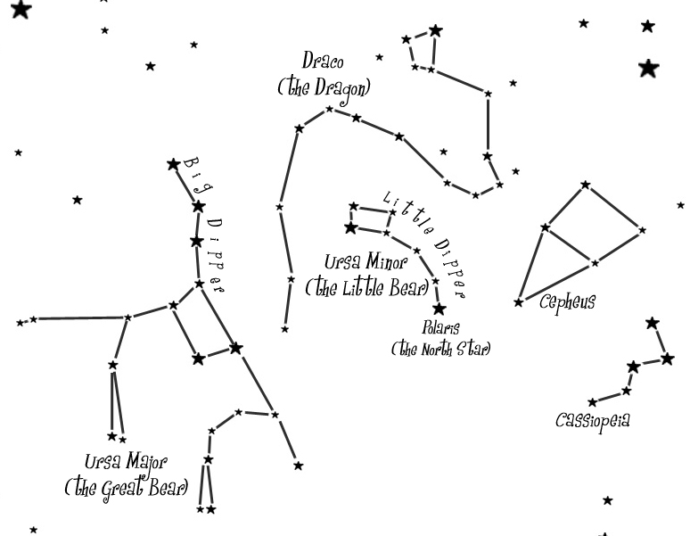

Northern Circumpolar Constellations

Depending on where you live, some constellations are visible all year round and some constellations are seasonal. If you live in the Northern Hemisphere, the constellations that circle around the North Star are visible all year. They are called circumpolar constellation because they travel in circles around the North Star. Because the circumpolar constellations are easily recognized and visible all year, they are a good place to start learning about the night sky. The main circumpolar constellations are Ursa Major, the Great Bear; Ursa Minor, the Little Bear; Draco, the Dragon; Cepheus, the King; and Cassiopeia, the Queen.

The circumpolar constellations travel in circles around the North Star, Polaris. If you take long exposure photographs of the North sky, you can see these ‘star swirls’. | 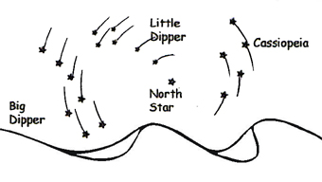

The Big Dipper  The Big Dipper is by far the easiest grouping of stars to recognize because five of the seven stars are very bright and can even be seen by people living in cities. However, the Big Dipper is not a true constellation. It is part of a larger constellation called Ursa Major, the Great Bear. The Big Dipper can be used as a quick guide for locating the North Star. |  | 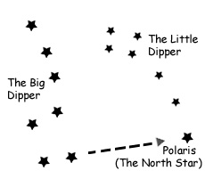
The two stars at the end of the spoon are called the pointer stars and if you follow a straight line through the two pointer stars upward, the next bright star you come across will be the North Star. The distance that you have to go is about five times the distance between the two pointer stars. Using the North Star, you can get your bearings on Earth.
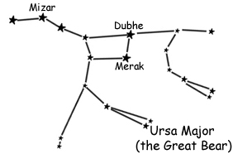 | Ursa Major, The Great Bear  Artemis, the moon goddess and goddess of the hunt, always had hunting companions with her when she went on the hunt. One such companion was Callisto, a beautiful young maiden.  One day Zeus passed by a woodland cove and spied the
sleeping Callisto. Zeus disguised himself as Apollo and made Callisto his lover. They had a child named Arcas. Of course Zeus knew that both Hera, his wife, and Artemis would be angry with Callisto so to protect her he turned her into a bear to keep her hidden from Artemis and Hera.

One day, Arcas was hunting and he came across a great bear. He was just about to shoot his arrow when Zeus intervened and changed him into a little bear so that Arcas could know who the great bear really was. Zeus then transported the two bears to the heavens so that they would be protected from the wrath of the angry goddesses.

However, Hera was unhappy that Callisto and her son were shining so brightly in the heavens so she asked the ocean god to prevent them from ever bathing in the ocean waters. And so, according to this story, that is why the two bears are forced to circle the heavens while the other constellations are allowed to dip below the horizon and bathe in the immortal waters every night.

Three important stars in Ursa Major are Mizar, Dubhe and Merak. Dubhe and Merak are also known as the pointer stars because they point to the North Star. Mizar was the first binary star that was ever discovered. A binary star is a star that orbits another star. In 1650, an Italian astronomer named Riccioli using a simple telescope discovered that there were indeed two stars orbiting each other, a fact which could not be seen by the naked eye. Since then many binary stars have been discovered.

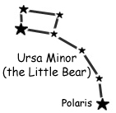 | Ursa Minor, the Little Bear  Ursa Minor is much harder to find than Ursa Major. Usually, it’s easier to find Ursa major first and follow the pointer stars to Polaris and then find the other stars of Ursa Minor.
One important star is Polaris, the Pole Star or the North Star. It is an important star for navigators because it stays relatively fixed in the heavens while all of the other stars move in circular arcs throughout the night. In the past, it has been called ‘the ship star’, ‘the leading star’, ‘star of the sea’ and the ‘steering star’.
Draco, the Dragon  The titans were giants with serpentine feet. They were almost invincible. When they revolted against the gods, they caused great destruction. During the battle, Athena grabbed the feet of one of these dragon-like giants and flung it into the heavens where it got tangled among the stars.  One interesting star is Thuban. Around 2700 BC, at the height of the ancient Egyptian civilizations, Thuban, not Polaris, was at the celestial north pole and was therefore the pole star. The pole star changes slowly because the Earth’s rotational axis wobbles (spins around like a top). |  | 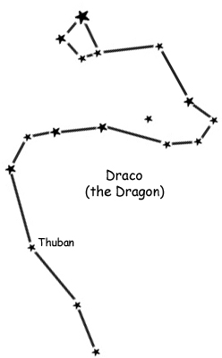

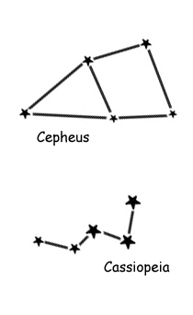 | The King and Queen, Cepheus and Cassiopeia  Cepheus and Cassiopeia were the king and queen of Joppa, a city in the land of Ethiopia. They had many children including a daughter named Andromeda. Andromeda was very beautiful and when the sea nymphs overheard Cassiopeia boasting about her beauty, they complained to Poseidon.  Poseidon got angry and sent a sea monster to destroy the city. When the monster was coming, Cepheus consulted an oracle. The oracle gave Cepheus a choice: Sacrifice his daughter Andromeda, or face the destruction of the monster. Cepheus agreed to sacrifice his daughter to save the people of his kingdom and so he chained Andromeda to a cliff.
As it happened, Perseus was flying past on his flying horse Pegasus. Perseus agreed to save the daughter in return for her hand in marriage. Perseus and Andromeda lived a long life. When they died they were transformed into the stars as constellations along with the King and Queen, Cepheus and Cassiopeia. Cassiopeia is sitting in her throne and Cepheus has his arms stretched out. However, as punishment, Poseidon made sure that Cassiopeia’s throne was dumped upside down every night (when the constellation forms and ‘M’ instead of a ‘W’.

Without looking at the first page, can you draw the five circumpolar constellations?


In some myths the monster is a squid-like creature called the Kraken and in other myths it is a giant whale named Cetus. In versions of the myth where Cetus is the monster, the story goes that Cetus was placed in the stars below Andromeda to chase her perpetually around the heavens.

