The pH Scale
Fill in the blanks with words from the box.
acidity | alkalinity |  | blue | high
hydrogen | hydroxide |  | indicators | low
neutral | pH |  | red | water
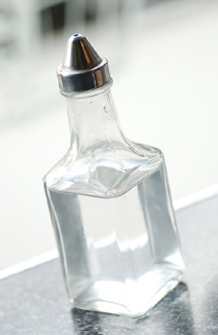  Vinegar, which is acidic, has a pH of 2.4. |  | Acids are substances that release _________________ ions into water. Bases are substances that release _________________ ions into water. An acid’s strength is called its _________________ and a base’s strength is called its _________________. The strength of an acid or base is measured using the _________________ scale which ranges from 0 to 14.
Strong acids have a _________________ number on the pH scale, whereas strong bases have a _________________ number on the pH scale. Substances that have an equal number of hydrogen and hydroxide ions are said to be _________________ and have a pH of around 7. Pure _________________ is an example of a neutral substance.
To determine the acidity or alkalinity of a substance people can use _________________ such as litmus. Litmus turns _________________ in acids and _________________ in bases. Some flowers such as hydrangeas can even act as indicators for the acidity or alkalinity of the soil in which they are growing. Hydrangeas usually grow blue or purple flowers in acidic soils and red flowers in alkaline soils. |  |  |  |  | 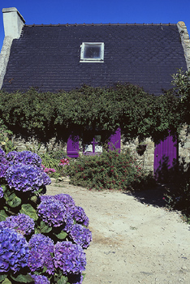  Hydrangea flowers turn blue in acidic soil.

