Universal Law of Gravity
Fill in the blanks with words from the box.
attraction | decreases |  | distance | fall
gravity | increases |  | mass | moon
Newton | orbit |  | sun | tides
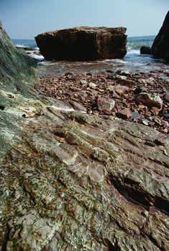  The gravitational pull of the Moon and the Sun cause tides on Earth. |  | The English scientist Sir Isaac _________________ developed the universal law of _________________. This law states that gravity is a force of _________________ between every object in the universe. This law also states that the force of attraction between two objects depends on two things: the _________________ of the objects and the _________________ between the objects. As the mass of the objects increases the force of gravity _________________. As the distance between the
objects increases the force of gravity _________________.
Gravity can be used to explain many of the things we observe in the universe. For example, gravity explains why objects _________________ to the ground when you drop them. This is because the Earth’s gravity is pulling on the object. Gravity also explains why the oceans have _________________. They are caused by the gravitational pull of the _________________ and the _________________. Gravity combined with the law of inertia can even explain why the planets _________________ the sun.

