Solutions Cloze
Fill in the blanks with words from the box.
alcohol |  | alloys |  | gas | homogeneous
salt |  | solid |  | solubility | solute
solution |  | solvent |  | temperature | water
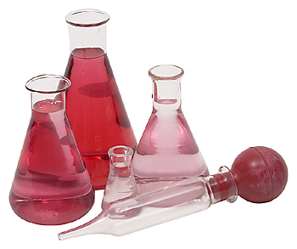  Some liquid solutions. |  |  | A _________________ is a special kind of mixture in which one substance is uniformly mixed into another. Mixtures in which one substance is uniformly mixed into another are called ________________ mixtures. Solutions can take many forms such as sugar water, which is a _________________ dissolved in a liquid, and
carbonated water, which is a _________________ dissolved in a liquid. Solutions can also include mixtures of two liquids like _________________ and water, and mixtures of gases such as air. Solutions even include mixtures of metals and other solids called _________________.
A simple solution is a combination of two substances. One substance called a _________________ dissolves the other. The substance that is dissolved is called the _________________. So for example, in salt water, _________________ is the solvent and _________________ is the solute.
The amount of solute that can be dissolved be a solvent is called the _________________. The solubility of a solid in a liquid usually increases as the _________________ increases. The solubility of a gas in a liquid usually increases as the pressure increases. |  |  |  |  |  | 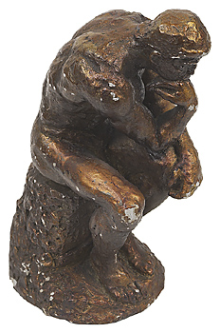
 | The statue to the right is made of an alloy, bronze, which is a solid solution of copper and tin.

