The Periodic Table
Fill in the blanks with words from the box.
atom | atomic number |  | column |  | element
gold | inert |  | Mendeleev |  | metals
nonmetals | periodic |  | properties |  | symbol
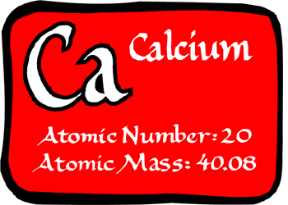  Calcium: an element on the periodic table with atomic number 20. | All matter is composed of various elements. An _________________ is a form of matter that is composed of a single type of _________________. In 1869, Dmitri _________________ created the _________________ table to group the elements. Periodic tables usually show the element name, the element _________________, and the atomic number.
As you go across a row from left to right, the _________________ of the element increases. The atomic number is the same as the number of protons in the nucleus of an atom. As well, elements that have similar _________________ are placed in the same _________________. For example, copper, silver, and _________________ all have similar properties and are all placed in column eleven of the periodic table. Elements on the left side of the table tend to have properties of _________________ and elements on the right side of the table tend to have properties of _________________. Elements in column 18, the last column on the left, are _________________ gases, which are gases that generally do not react with other elements.
 |  | Neon is one of the inert gases, which are located in column 18 of the periodic table. Inert gases do not normally react with other elements. |  | 