Newton’s Laws of Motion
Fill in the blanks with words from the box.
acceleration | decreases |  | equal | force
increases | inertia |  | mass | motion
Newton | opposite |  | reaction | rest
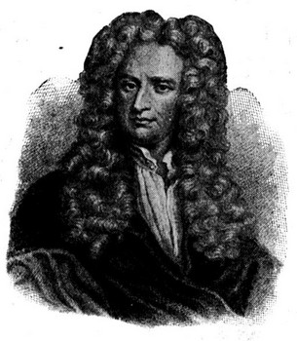  Sir Isaac Newton |  | The English scientist Sir Isaac _________________ developed three laws of motions. His first law is called the law of _________________. This law states that objects in motion will stay in _________________ and objects at rest will stay at _________________ unless acted upon by an unbalanced _________________.
Newton’s second law of motion states that an unbalanced force is equal to _________________ times _________________. This means that as more unbalanced force is applied to an object, its acceleration _________________. It also means that as an object’s mass increases, the acceleration _________________ for a given unbalanced force.
Newton’s third law of motion states that for every action there is an _________________, but _________________ reaction. This means that whenever one object pushes on another object, the other object pushes equally hard back.

