Mixtures: Suspensions, Colloids, and Solutions
Fill in the blanks with words from the box.
chemical | colloid |  | heterogeneous | homogenous
light | microscope |  | milk | mixture
muddy | settles |  | solution | suspension
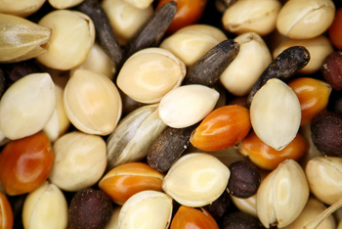  A mixture |  | A _________________ is a combination of two or more substances in which the substances don’t form _________________ bonds with each other. There are many kinds of mixtures. Some mixtures are chunky like a mixture of peanuts and raisons. These mixtures are called_________________ mixtures.
Some mixtures with large particles separate by themselves over time. _________________ water for example will become clear as the mud _________________ to the bottom. These mixtures are called _________________. The particles in a suspension are often big enough to be seen with the naked eye and can block out light.
Another kind of mixture called a _________________ has particles small enough that the particles don’t settle, yet large enough that they can still block out _________________. Smoke and _________________ are examples of colloids.
Sugar water is a different kind of mixture called a _________________. In solutions, the particles are so small that they don’t block light or settle to the bottom. The substances mix uniformly so that the mixture looks the same everywhere, even under a _________________. Mixtures that are uniform everywhere are called _________________ mixtures. |  |  |  |  | 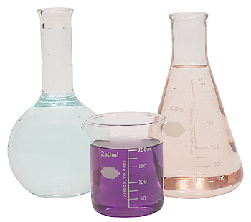  A solution

