Magnetism Cloze
Fill in the blanks with words from the box.
attract | aurora borealis |  | compass |  | field
force | iron |  | lines |  | nickel
north | poles |  | repel |  | stronger
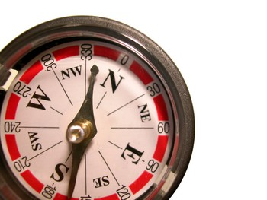  A compass uses the Earth’s magnetic field to point to north. |  | Magnetism is a _________________ that has the ability to push or pull some objects such as metals like _________________ or _________________. Magnets have two ends called _________________. When you bring two magnets together, like poles _________________ each other and opposite _________________ attract.
If you sprinkle iron filings around a magnet, they will form _________________ showing the direction of the magnetic force. These lines of magnetic force are called a magnetic _________________. The closer the lines are together the _________________ the force.
The Earth generates a magnetic field as well. For centuries, sailors have used this magnetic field to help them find _________________ on cloudy days and nights using a tool called a _________________. The Earth’s magnetic field also causes one of the wonders of nature, the _________________, which is produced when charged particles in space are pulled into the Earth’s atmosphere by the Earth’s magnetic field. |  |  |  | 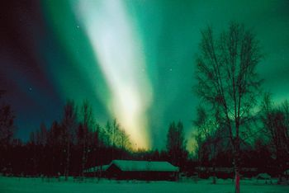  The Earth’s magnetic field causes the aurora borealis.

