Light Cloze
Fill in the blanks with words from the box.
absorb | electromagnetic |  | medium | opaque
prism | rainbow |  | reflects | refraction
shadows | translucent |  | transparent | white
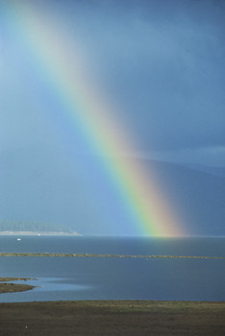  Rainbows form when  sunlight is refracted  by water droplets. |  | Light is a visible form of _________________ radiation. The sun produces _________________ light, which is a combination of all the colors of light. However, these colors can be separated using a device called a _________________. A prism uses the property of _________________, which is the bending of light as it passes from one _________________ to another. A _________________ is formed when the sun’s light is refracted through droplets of water in the atmosphere.
We see objects when light _________________ off of them. Different objects appear to be different colors because of the way light reflects off of the objects. Blue objects _________________ every color except blue, which is reflected. Light can also pass through objects. Objects that allow light to pass through them are _________________. Objects that blur light as it passes through are called _________________. Objects that block light completely are _________________. Opaque objects form _________________ under them when light shines on them.

