Heat Cloze
Fill in the blanks with words from the box.
conduction | convection |  | dense | Earth
energy | kinetic |  | liquids | radiation
rise | temperature |  | thermometer | vibrating
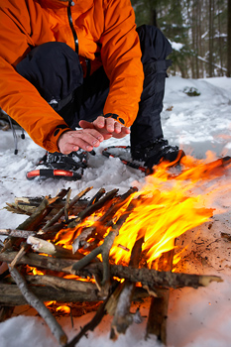  Keeping warm by the fire. |  | Heat is a form of _________________ that moves from hot things to cold things. In other words, heat is energy that flows from objects with a high _________________ to objects with a low temperature. Temperature is the average _________________ energy of the particles in an object and is measured using a _________________.  Heat can move from object to object in three ways. One way that heat flows is called _________________, which occurs when two objects are touching. In
conduction, the particles in the high temperature object are _________________ quickly compared to the low temperature object. When the particles in the high temperature object bump into the particles in the low temperature object, the low temperature object’s particles begin to vibrate more quickly. Another form of heat transfer is _________________, which occurs in _________________ and gases. In convection, the part of the liquid or gas with high temperature is less_________________ than the part with low temperature so the high temperature parts _________________ and the low temperature parts sink.
In both conduction and convection, heat is transferred through a material. However, heat energy can also travel through empty space in a third way called _________________, which is how heat travels from the sun to the _________________.

