Electromagnetism Cloze
Fill in the blanks with words from the box.
cars | coils |  | currents | electromagnetism
fans | generator |  | hydroelectric | kinetic
magnetic | motor |  | spins | turbine
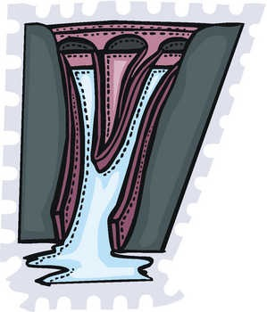  Hydroelectric generators convert the kinetic energy of water flowing downhill into electricity. |  | Magnetism and electricity are connected in a way that is very useful to people. Magnetic fields can be used to generate electric _________________ and electric currents can be used to generate _________________ fields. This connection between magnets and electricity is called _________________. How does this work? As a_________________ of wire spins in a magnetic _________________, a current flows through it.
A device that uses a coil of spinning wires in a magnetic field to make electricity is called a _________________. A _________________ power plant, for example, uses the energy of flowing water to generate electricity. As water flows from a high place to a low place, it pushes on _________________ blades causing them to spin. Coils of wire are attached to the spinning turbine and placed next to magnets. As the coil _________________ in the magnetic field, electric current flows through the wires. In short, the _________________ energy of water is transformed into electrical energy.
This process can be reversed to produce an electric _________________. An electric current through a coil of wires in a magnetic field will cause the coil to start spinning. This coil is attached to an axle, which can be used to move something else such as a wheel or a blade. _________________ and toy cars are examples of devices that use an electric motor to generate motion.

