Electric Circuits Cloze
Fill in the blanks with words from the box.
battery | circuit |  | closed | conductors
current | fuse |  | heat | open
resistors | short |  | switch | voltage
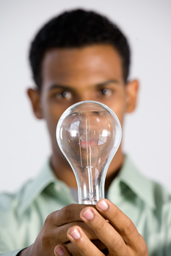  Light bulbs convert electrical energy into light. |  | An electric _________________ is a flow of electricity though a material. Materials that allow electricity to flow through them are called _________________. An electric _________________ is a path though which electric currents flow. In order to start the current flowing, a circuit needs a _________________ source such as a _________________.
Many circuits have a _________________, which is a device to open and close the circuit. When the circuit is _________________, the electric current does not flow When the circuit is _________________, current does flow.

Circuits also have _________________, which are objects that resist the flow of electricity. Resistors can be used to transform electrical energy into other forms of energy such as _________________ or light. A light bulb is a resistor that transforms electrical energy into light energy.

Without resistors, electricity can travel too quickly through a circuit damaging the parts of the circuit. When this happens it’s called a _________________ circuit. A _________________ is a safety device that prevents short circuits by breaking the circuit when too much current is traveling through it.

