Atoms and Elements
Fill in the blanks with words from the box.
atoms | carbon |  | electrons | element
mass | negative |  | neutrons | nucleus
positive | properties |  | protons | space
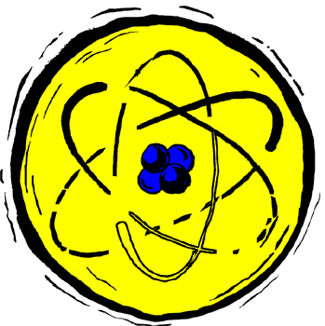  A model of an atom showing a nucleus in the center and electrons moving around the nucleus. |  | Matter is anything that has _________________ and takes up _________________. An _________________ is matter that cannot be broken down into anything simpler by a chemical reaction. Copper, oxygen, and _________________ are examples of elements.
If you kept trying to divide an element into smaller and smaller pieces eventually you would come to a piece of that element that cannot be divided further. These smallest indivisible pieces of elements are called _________________. An atom is the smallest unit of an element that keeps the _________________ of the element.
All atoms of every element are composed of smaller particles. The center of each atom, called the _________________, contains _________________ and _________________. Moving around the atom on the outside of the nucleus there are _________________. Protons have a _________________ charge whereas electrons have a _________________ charge. Neutrons have no charge at all.

