Alloys
Fill in the blanks with words from the box.
alloy | altered |  | brass | bronze
chromium | flexible |  | hard | mixture
properties | rusts |  | stainless | steel
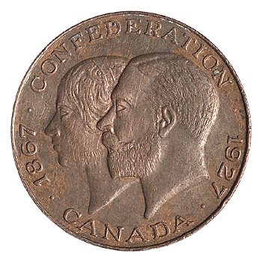  A bronze coin |  | An _________________ is a special kind of _________________ of a metal with another substance. _________________ is an alloy of the metal copper and the metal tin. _________________ is an alloy of the metal iron and the nonmetal carbon as well as other metals such as chromium and nickel.
People use alloys because they can make materials with the _________________ they need. For example, _________________, which is used to make musical instruments, is an alloy of copper and zinc. Copper is soft and flexible, whereas zinc is hard and brittle. Combined together they make a material that is _________________ and_________________.
The properties of steel can also be _________________ by changing the amounts and types of substances used to make the steel alloy. One problem with iron is that it _________________ when it gets wet. However, when _________________ is added to steel alloys it forms a special kind of steel called _________________ steel. The advantageous of this kind of steel is that it is hard but it doesn’t rust easily. |  |  |  |  | 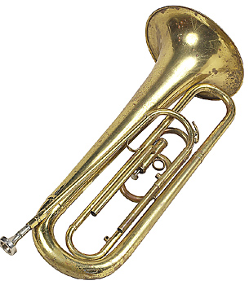  A brass trumpet

