Acids and Bases Cloze
Fill in the blanks with words from the box.
acid | bitter |  | burn | digest
hydrochloric | hydroxide |  | ions | litmus
metals | soapy |  | sour | vinegar
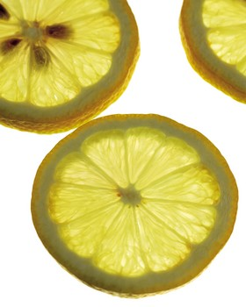  Lemons have citric acid. |  | Acids: An _________________ is a compound that contains hydrogen and releases hydrogen _________________ (H⁺) in water. Acids often taste _________________ and many acids can _________________ you if you touch them. Another property of acids is that they react with _________________ to produce hydrogen gas as the acid dissolves the metal material.
There are many different kinds of acids. Lemon juice and _________________ are examples of acids. There is even a very strong acid in your stomach called _________________ acid. This acid helps you _________________ food. You can use blue_________________ paper to determine if something is acid or not because the acid will turn the paper red.
Bases: Bases on the other hand are compounds that contain an oxygen-hydrogen combination called a _________________. When placed in water hydroxides form hydroxide ions (OH⁻). Bases feel _________________ when you touch them and taste _________________. Many household cleaners are bases. Some bases can even dissolve hair and food, which makes them ideal for clearing clogged drains. |  |  |  |  | 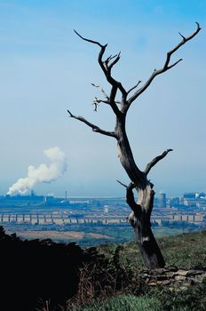  Some pollutants can cause acid rain.

