Plant Classification Crossword II
www.science-teachers.com/life.htm

Across
2 A powdery substance that helps seed plants produce seeds. (6)
5 Ferns produce these to make new ferns. (6)
6 The group of flowering plants. (10)
7 A tree that loses its leaves each year. (9)
10 monocots typically have these veins in their leaves. (8)
12 A plant that produces seeds but not flowers. (10)
15 A cone bearing gymnosperm such as a pine or fir tree. (7)
16 The process of moving pollen from a male flower or cone to a female flower or cone. (11)
Down  1 What pines and fir trees produce instead of flowers. (4)  3 A plant that lacks a system of vessels for transporting water and nutrients. (11)  4 Flowering plants that produce seeds with a single cotyledon. (7)  8 A plant like a fern that does not produce seeds. (8)  9 Dicots typically have these veins in their leaves. (8)  11 A tree that doesn’t lose its foliage in winter or the dry season. (9)  13 A flowering plant that produces seeds with two cotyledons. (5)  14 This sweet food often protects angiosperm seeds. (5) | 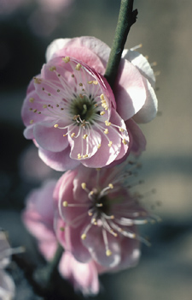  Cherry blossom trees produce flowers and are classified as angiosperms.

