Plant Classification Crossword
www.science-teachers.com/life.htm

Across
2 Dicots typically have these veins in their leaves. (8)
5 Where conifer seeds are found. (4)
6 monocots typically have these veins in their leaves. (8)
9 A tree that keeps its foliage all year round. (9)
11 Where angiosperm seeds are often found. (5)
12 The process of moving pollen from a male flower or cone to a female flower or cone. (11)
13 A tree that loses its leaves each year. (9)
14 A plant like a fern that does not produce seeds. (8)
15 A flowering plant that produces seeds with two cotyledons. (5)

Down  1 A plants that has a vessel for transporting water and nutrients throughout the plant. (8)  3 A cone bearing gymnosperm such as a pine or fir tree. (7)  4 A powdery substance that seed plants produce to make seeds. (6)  7 A flowering plant. (10)  8 Flowering plants that produce seeds with a single cotyledon. (7)  10 A plant that produces seeds but not flowers. (10)  14 What ferns produce instead of seeds. (6) |  | 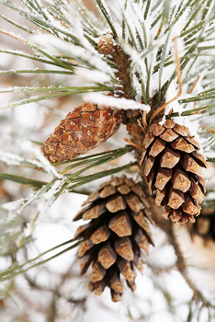  Pine trees produce cones and so are classified as conifers.

