  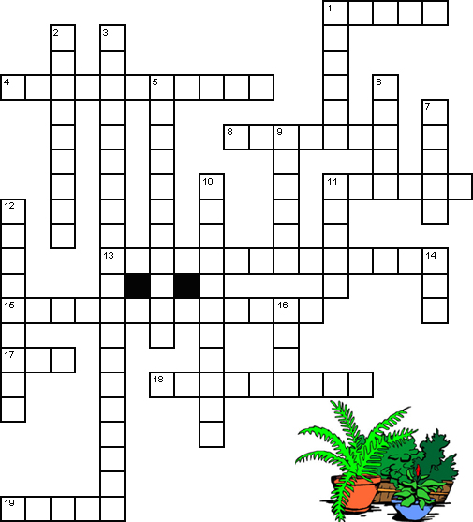 |  |  | Across  1 The product of photosynthesis. (5)  4 Process by which carbon circulates around the earth as plants remove carbon from the atmosphere and animals add carbon to the atmosphere. (6,5)  8 Specialized structures that allow gas to enter and leave the leaf. (7)  11 Part of the plant where photosynthesis generally occurs. (6)  13 The process by which plants and some bacteria use the energy from sunlight to produce sugar. (14)  15 A compound needed for photosynthesis. (6,7)  17 Molecule used to store energy. (3)  18 flattened sacs or vesicles containing photosynthetic chemicals (9)  19 Chlorophyll absorbs every color of sunlight except this. (5)
Down  1 Place where dark reactions occur. (6)  2 An animal that eats plants. (9)  3 the process of converting energy from a light-excited electron into the pyrophosphate bond of an ADP molecule. (20)  5 A group of accessory pigments that includes beta-carotene. (11)  6 Place where light reactions occur. (5)  7 A compound needed for photosynthesis. (5)  9 A by-product of photosynthesis. (6) | 10 A plant pigment that absorbs sunlight. (11)  11 This reaction requires direct energy of sunlight to make energy carrier molecules. (5)  12 The links between the energy that carnivores get from eating to the energy captured by photosynthesis. (4,5)  14 Number of molecules of oxygen produced along with one molecule of sugar. (3)  16 Reaction that occurs when the products of the Light Reaction are used to form C-C covalent bonds of carbohydrates. (4)

