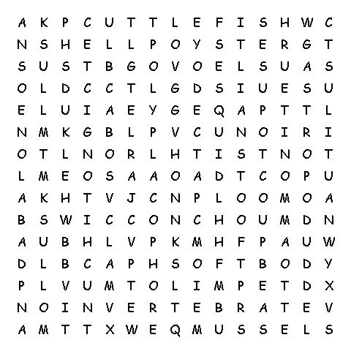  www.science-teachers.com/life.htm |  |  |  |   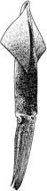  mollusk  foot  invertebrate  shell  soft body
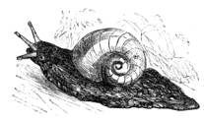  gastropod  abalone  conch  limpet  nudibranch  slug  snail  whelk | 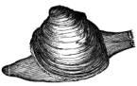  bivalve  clam  mussel  oyster  scallop | 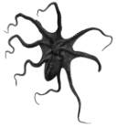  cephalopod  ammonite  cuttlefish  nautilus  octopus  squid | 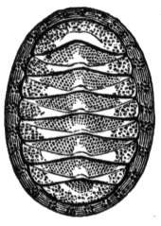  polyplacophore  chiton

