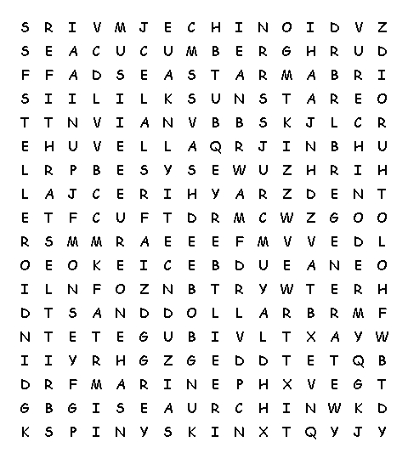  www.science-teachers.com/life.htm |  |  |  |   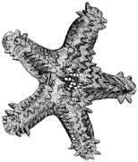  echinoderm  spiny skin  marine  invertebrate  tube feet  radial symmetry  five-sided  regenerate
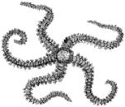  stelleroid  sea star  sun star  brittle star | 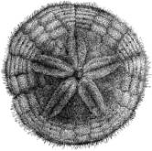  echinoid  sea urchin  sand dollar | 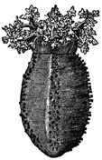  holothuroid  sea cucumber | 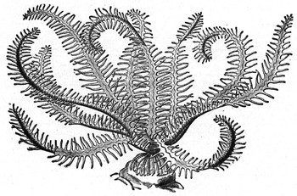  crinoid  feather star  sea lily

