  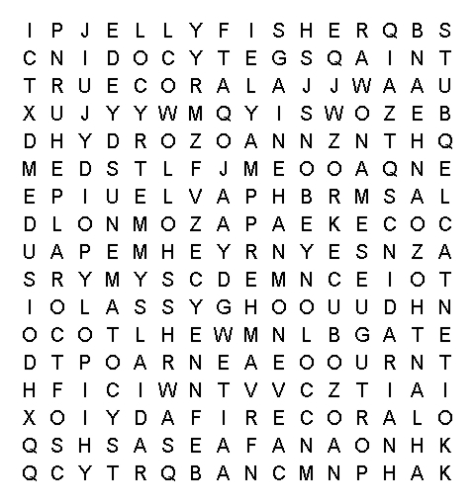  www.science-teachers.com/life.htm |  |  | 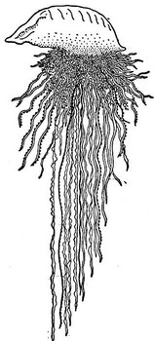  cnidarian  polypoid  medusiod  hollow  colony  regenerate  radial symmetry  tentacle  cnidocyte  nematocyst  venom
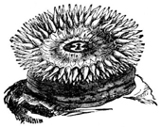  anthozoan  true coral  anemone  sea fan  sea pen  soft coral | 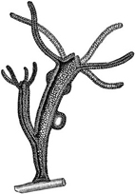  hydrozoan  hydra  fire coral  Portuguese man-o'-war | 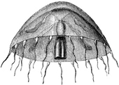  scyphozoan  jellyfish  cubozoan  box jelly

