  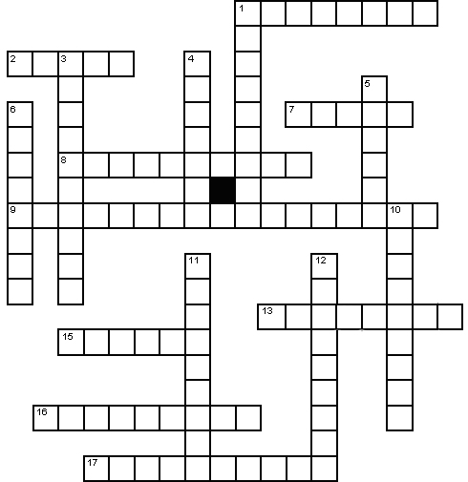 |  |  | Across  1 Cnidarians such as box jellyfish. (8)  2 An anthozoan that lives in colonies that secretes a hard outer skeleton. (5)  7 A poison injected by nematocysts. (5)  8 The stinging mechanism in a cnidocyte. (10)  9 A hydrozoan that is actually a colony of four types of special polyps that depend on each other for survival. It’s known for its sail and long tentacles. (10,3-1-3)  13 A shape with mouth and tentacles pointing downward like a jellyfish. (8)  15 The type of symmetry exhibited by cnidarians. (6)  16 An animal with stinging cells such as an anemone or a jellyfish. (9)  17 A cnidarian such as a jellyfish (10)
Down  1 A stinging cell in a cnidarian. (9)  3 To grow again. (10)  4 A polypoid anthozoan. (7)  5 Empty space. (6)  6 A shape with mouth and tentacles pointing upward like an anemone. (8)  10 A cnidarian such as a coral, sea fan, or an anemone. (9)  11 A scyphozoan with medusoid shape. (9)  12 A cnidarian such as a hydra or a fire coral. (9) | 