www.science-teachers.com/life.htm

Across
1 Clams, squid, and snails. (8)
4 Humans, monkeys, and gorillas. (8)
5 Mice, rats, and hamsters. (7)
9 Frogs, salamanders, and toads. (10)
11 Lizards, snakes, and turtles. (8)
12 Crabs, shrimp, and lobsters. (11)
13 Tuna, salmon, and goldfish. (4)
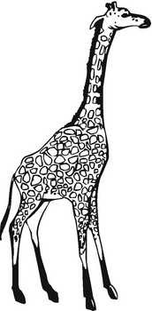
Down
1 Horses, humans, and whales. (7)
2 Jellyfish, anemones, and coral. (10)
3 Bees, beetles, and ants. (7)
6 Starfish, sand dollars, and sea urchins. (11)
7 Kangaroos, koalas, and wombats. (10)
8 Dolphins, killer whales, and whales. (9)
10 Hawks, parrots, and sparrows. (5)

