Plant Classification Cloze
Fill in the blanks with words from the box.
angiosperms | classified |  | cones |  | dicots
flowers | gymnosperms |  | monocots |  | nonvascular
pine | seedless |  | seeds |  | vascular
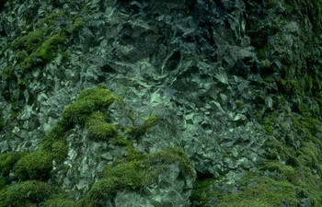  Mosses and other nonvascular plants lack vessels to transport nutrients and water throughout their bodies. |  | Plants are often _________________ according to the structures that they have in common. One of the most basic structures used to classify plants is a series of tubes for transporting water and nutrients in plants called a _________________ system. _________________ plants such as mosses usually grow close to the ground because they lack
this system for moving water and nutrients from their roots to their extremities.
The vascular plants can be further grouped into two groups according to whether or not they make _________________. _________________ plants such as ferns make spores instead of seeds. The seed plants can also be further divided into two groups, the _________________ and the _________________. Angiosperms are plants that produce _________________. Gymnosperms such as _________________ and fir trees produce _________________ instead of flowers. The flowering plants can be further classified according to their leaf and seed structure. Plants with branching veins in their leaves are called
_________________ and plants with parallel veins in their leaves are called _________________.  Maple trees are dicots . You can see this because their veins are branching. |  |  |  | 