Animal Organ Systems Cloze
Fill in the blanks with words from the box.
cells | circulatory |  | digestive | endocrine
excretory | muscular |  | nervous | organs
respiratory | skeletal |  | systems | tissues
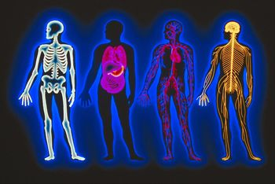  Can you identify the organ systems  shown in the picture above? |  | _________________ are the basic building blocks of living organisms. Cells work together with similar cells and form _________________. These tissues then combine to form _________________, which in turn are connected together in organ _________________.
Your lungs, for example, are part of the _________________ system, which is responsible for bringing oxygen into your body and releasing carbon dioxide into the atmosphere. Your heart is part of the _________________ system, which is responsible for circulating blood containing food and oxygen to all of the cells in your body. Your stomach is part of the _________________ system, which is responsible for breaking down food so that your cells can use it. Your kidneys are part of the _________________ system, which is responsible for eliminating waste from your body. Your bones are part of the _________________ system, which give your body structure. Your muscles are part of the _________________ system, which allows your body to move. Your brain is part of the _________________, which controls muscle movement and your senses. Finally, your glands are part of the _________________ system, which produces hormones that regulate your body.

