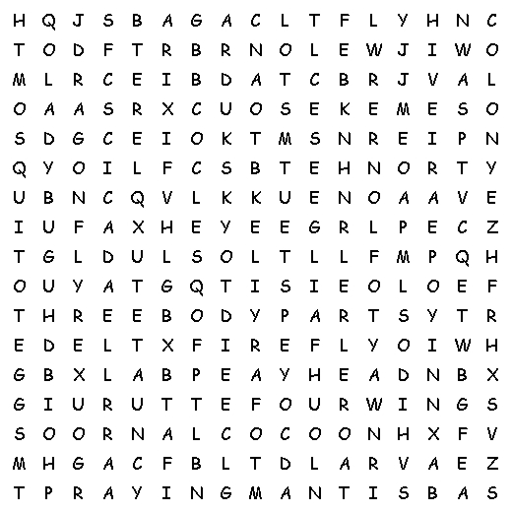 |  |  | 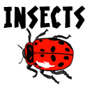  three body parts  four wings  six legs  head  thorax  abdomen  antennae  exoskeleton  moult  cocoon  colony  hive  egg  grub  larva  caterpillar
Insects:  ant  bee  beetle  butterfly  cicada  cockroach | cricket  dragonfly  firefly  flea  fly  grasshopper  horsefly | ladybug  mosquito  moth  praying mantis  stick bug  termite  wasp
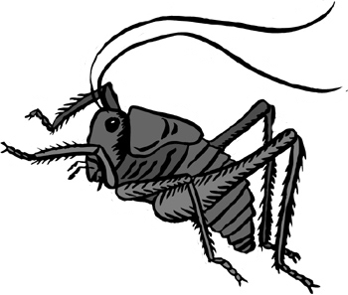 | Find all of these insect words and phrases in the grid above.

© 2005 www.science-teachers.com

