Relationships in Ecosystems Cloze
Fill in the blanks with words from the box.
alga | commensalism |  | ecosystem | fungus
interact | lichen |  | mutualism | parasitism
predator | prey |  | symbiosis | tapeworms
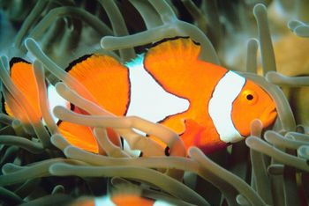  An example of mutualism: clownfish protect anemones and anemones protect clownfish. |  | Living things _________________ with one another in their environment. All of the living and nonliving things within an environment along with their interactions is called an _________________. One simple type of interaction is a _________________-_________________ relationship in which one
animal hunts another. In general, long lasting relationships between organisms is called _________________. Symbiotic relationships can benefit one or both of the organisms involved and can harm one or none of the organisms involved. A symbiotic relationship in which both organisms benefit is called _________________. An example of this kind of relationship is _________________, which is composed of an _________________ and a _________________. The alga gives the fungus food and oxygen and the fungus provides a home and nutrients. Another symbiotic relationship between organisms is called _________________. In this relationship one organism benefits but the other is not harmed. A kind of bird called a cattle egret follows cattle because the cattle expose insects for the bird to eat when the cattle graze. The bird benefits but the cattle are not harmed. A third kind of symbiotic relationship called _________________occurs when one organism benefits, but the other is harmed. Lampreys, _________________, fleas, and lice are some examples of parasitic animals.

