
Echinoderms: An Introduction  Echinoderms are marine animals that are often found attached to rocks. Echinoderm means ‘spiny skin’ and includes sea stars, brittle stars, featherstars, sea urchins, sand dollars, and sea cucumbers. Echinoderms are characterized by a water vascular system with tube feet and radial symmetry. |  | 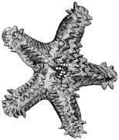
Symmetry:

As adults most, but not all, echinoderms exhibit five-sided radial symmetry. Their body acts as a hub with five arms, or rays, projecting outwards. For sea stars and brittle stars the symmetry is easy to sea, but if you observe other echinoderms carefully, the symmetry is there as well. At the center of the sand dollar, there is what looks like a flower with five petals. If you remove the spines from a sea urchin, you can observe five bands radiating outward. Similarly, if you stand a sea cucumber on its end, you will observe five rows of tube feet extending down the length of its body.

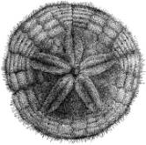  A Sand Dollar with ‘Flower’ in the Center | 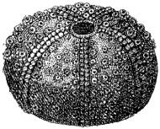  A Sea Urchin with Five Bands Radiating Outwards | 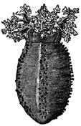  A Sea Cucumber with Five Bands of Tube Feet
Although five-sided radial symmetry is common among echinoderms, some echinoderms such as sun stars have 20 or more arms projecting outwards. As larvae, echinoderms exhibit bilateral symmetry.

Water Vascular System and Movement Using Tube Feet

Along with radial symmetry, another defining characteristic of echinoderms is a water vascular system. This water vascular system is used for gas exchange, feeding, and locomotion. The water vascular system extends to their tube feet called podia. When echinoderms move, they force water into the podia, which causes them to expand. Echinoderms also have muscles attached to the podia, which they can use to retract the podia. This system of expansion by forcing water into the podia and then contraction by muscle allows echinoderms to move.

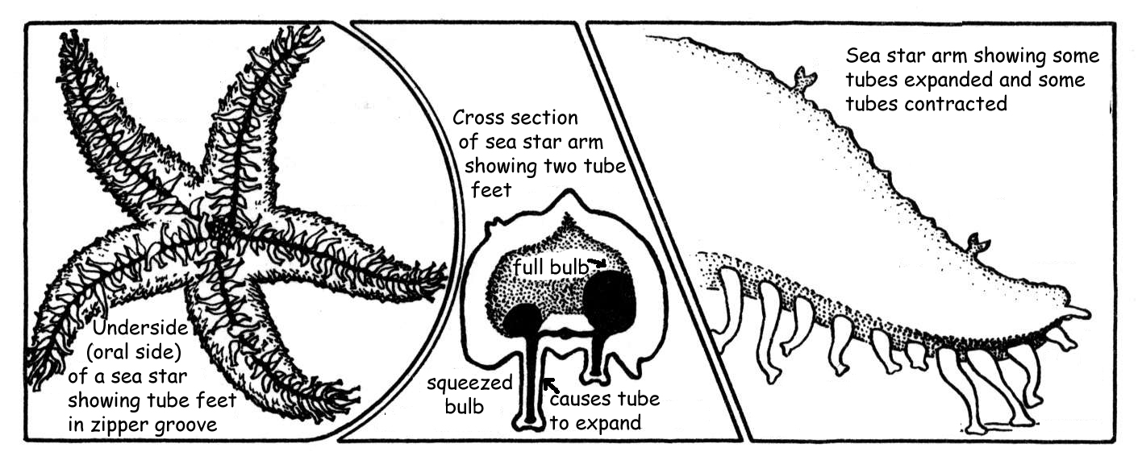
Sea Stars (Starfish)

Sea stars fall under the class Stelleroidea. There are two main subclasses of sea stars: Asteroidea and Ophiuroidea. Asteroids are the true sea stars and sun stars. Ophiuroids are composed of brittle stars and basket stars. The main difference between asteroids and ophiuroids is the way that the rays, or arms, attach to the body. In ophiuroids, the arms are not joined to each other and the body and arms are clearly separated, but in the asteroids the arms are joined to each other and the boundary between arms and the central disc is blurred.
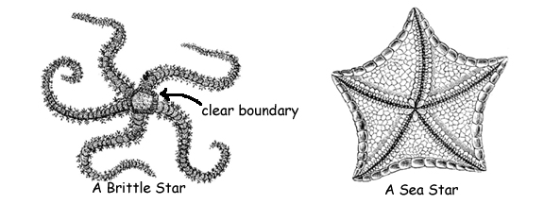

Sea stars eat many things including clams, mussels, barnacles, coral, sea urchins and even other sea stars. Some sea stars have a remarkable way of eating shells. They pry the shell open just slightly with their powerful arms and then they insert their stomach into the shell. When they are finished, there is nothing but an empty shell left.

Sea Urchins and Sand Dollars

Sea urchins and sand dollars are echinoids from the class Echinoidea. Spines radiating outwards protect them from predators. The spines are connected to the skeleton by a ball joint and muscle, which can swivel towards a predator. Echinoids are herbivores, grazing on algae on rocks and the sea floor. They have five bands of tube feet, which they use to move around and cling to rocks. |  |  | 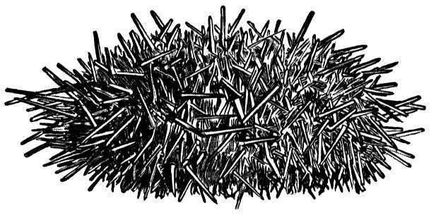  A Sea Urchin with Spines
 |  | Sea Cucumbers
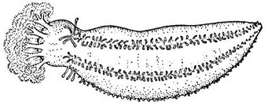  A Sea Cucumber: A Filter Feeder |  | Sea cucumbers belong to the class Holothuroidea. They get their name because some sea cucumbers look like vegetable cucumbers. Sea cucumbers have five rows of tube feet along their
sides and tentacles around their mouths. The tentacles filter seawater or sand for plankton and other organic matter.

Regeneration

Sea Stars and Sea cucumbers have a special characteristic: they can regenerate (re-grow) lost body parts. If you cut an arm off of a starfish, it will be able to regenerate that arm. Sometimes, even the separated arm can become a whole new sea star. This makes sea stars very hardy and can even cause some problems. For example, the crown-of-thorns starfish damages coral reefs, but because of its regenerative properties, it is very hard to kill. Sea cucumbers have the amazing ability to eviscerate (expel) their internal organs, when attacked. The predator is often satisfied with this easy meal and moves on. The sea cucumber then regenerates the expelled organs.

