Competition in Ecosystems Cloze
Fill in the blanks with words from the box.
community | compete |  | carrying |  | ecosystem
limiting | soil |  | niche |  | population
resources | survive |  | sunlight |  | water
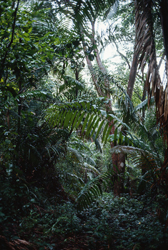  Trees in a rainforest  compete for sunlight |  | All living organisms must _________________ with other organisms to _________________. This competition prevents the unlimited growth of an organism’s _________________, which is the number of that kind of plant or animal in an _________________. Organisms compete both with other organisms within their own species and with organisms of other species. Competition exists throughout the _________________, which is all of the populations within an ecosystem taken together.
This competition exists because _________________ are limited. Any resource that restricts the growth of a population is called a _________________ factor. Limiting factors can include things like _________________, temperature, _________________, availability of food sources, and _________________
type. The maximum population of a particular organism that an ecosystem can support is called the _________________ capacity. Some organisms avoid competition by finding a _________________, which means specializing by using resources in a habitat that other organisms cannot or do not compete for. |  |  |  | 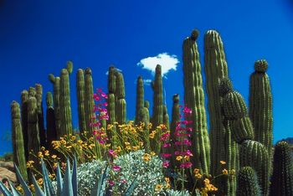  These cactuses avoid competition for sunlight by thriving in a niche where other plants cannot grow.

