Cell Structures Cloze
Fill in the blanks with words from the box.
cells | chloroplasts |  | energy | membrane
mitochondria | nucleus |  | organelles | photosynthesis
plant | vacuoles |  | wall | water
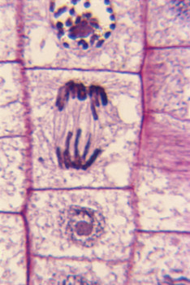  Cells seen under the microscope. Note how the nucleus of one cell is splitting. |  | All living organisms are composed of microscopic building blocks called _________________. These cells have many different basic structures in common called _________________. For example, cells are surrounded by a cell _________________ which controls the materials that move in and out of a cell. Another structure that most cells have in common is a _________________ in the center of the cell, which contains the blueprints for the cell’s growth and reproduction. Cells also have structures
called _________________ that break down food and supply _________________ for the cell to use. _________________ are structures that store food and _________________ for the cell to use later.
Although plant and animal cells have many similarities there are also some important differences. _________________ cells usually have one very large vacuole. This large vacuole helps prevent drying out during dry spells. Plant cells also have a thick cell _________________ surrounding them as well as a cell membrane. Another difference between plant and animal cells is that plants have organelles called _________________, which help plants capture the sun’s energy to be used for _________________.

