Animal Adaptations Cloze
Fill in the blanks with words from the box.
adaptation | behavioral | camouflage |  | coloring
hibernation | resemblance | mimicry |  | migration
nocturnal | roots | stems |  | structural
Any body part or behavior that helps an animal survive in its environment is called an _________________. There are two kinds of adaptations, structural and behavioral. _________________ adaptations are body parts such as claws, long necks, colored skin, and strong muscles. _________________ adaptations are behaviors such as living in groups and hunting in packs. Desert plants for example have thick _________________ to help store water and _________________ that spread out to gather what little rain falls. Desert animals are often _________________ which helps them avoid water loss from the day’s heat. One important structural adaptation is _________________, which is any coloration or body shape that helps an animal blend in with its environment. Camouflage can be divided into two kinds, protective coloring and protective resemblance. Protective _________________ is when an animal skin or fur has colors that make it hard to see in its environment. Protective _________________ is when the animal’s body shape looks like something in its environment the way a walking stick insect looks like a twig. _________________ is another structural adaptation where an animal looks similar to another more dangerous animal, which helps to frighten predators
away. Important behavioral adaptations include _________________ to avoid harsh weather conditions or to find safe breeding grounds and _________________ to conserve energy at times when food is scarce. |  |  | 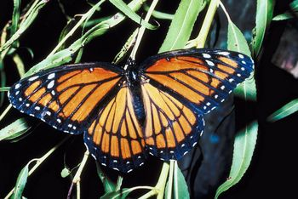  This non-poisonous viceroy butterfly looks nearly identical to the poisonous monarch butterfly.

