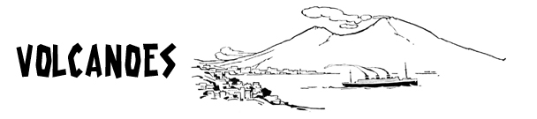
www.science-teachers.com/earth.htm

Across
2 Fine particles of pulverized rock blown from an explosion vent. (3)
5 A crack or fracture in the earth's surface. (5)
6 Molten rock at the surface. (4)
8 Large volcanoes with steep slopes that commonly collapse or explode at the top, giving them a bowl for a crater. (9)
10 The area of the earth that is below the crust. (6)
12 A smaller volcano with steep slopes. A volcanic cone built entirely of loose fragmented material. (6,4)
Down  1 An event when a volcano ejects gas, liquid and solid materials into the atmosphere and surrounding area. (8)  2 A volcano that is erupting or has erupted recently. (6)  3 To temporarily move people away from danger. (8)  4 Molten rock under the surface. (5)  7 A volcano that has not erupted for a long time but may erupt again some time in the future. (7)  9 Very broad volcano with gentle slopes formed from basalt lava flows. (6)  11 A volcano that hasn’t erupted in a long time and is unlikely to erupt  again. (7) |  | 