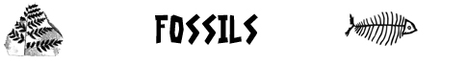  www.science-teachers.com |  | Name: __________________________
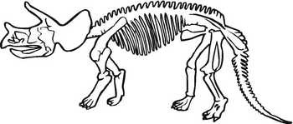 |  |  |  | Across  1 Sedimentary rock formed from sand deposits. (9)  3 The kind of rock that you are most likely to find fossils in. (11)  5 The process of changing the hard parts of the remains of an animal or plant with minerals. (11)  7 Sedimentary rock formed from deposits of shells. (9)  10 A fossil that look like a spiral or a rams horns. (8)  11 ______________ wood. A permineralized piece of wood. (9)  13 A kind of fossil where an animal or plant leaves only its body impression in the mud. (4)  14 Preserved in ice or snow. (6)  15 Kind of animals most likely to be preserved. (7)  16 Some insect fossils are trapped in this rock made from tree sap. (5)
Down  2 Sedimentary rock formed from clay deposits. (5)  4 Someone who studies ancient life. (14)  6 The science of studying ancient life. (12)  8 Preserved in hot, dry conditions. (9)  9 Fossils such as footprints, burrows, and droppings. (5)  12 Not preserved (7) | 