  www.science-teachers.com |  | Name: __________________________
 |  |  |  | 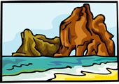  Find all of the terms listed below in the grid:  abrasion  arete  beach  cirque  creep  crevasse  deflation
dune  dune movement  glacial drift  glacier  hanging valley  horn | iceberg  landslide  loess  longshore current  mass movement  mudflow |  | rock fall  saltation  shoreline  stratified drift  till  u shaped valley

