Clouds Cloze
Fill in the blanks with words from the box.
altitudes | cirrus |  | clouds | condenses
cumulus | fair |  | fog | front
layers | masses |  | precipitation | stratus
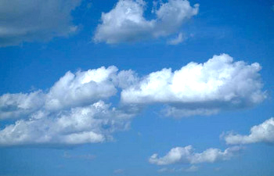  Cumulus clouds |  | _________________ form when moisture in the air condenses to form tiny droplets of water or crystals of ice. There are many different kinds of clouds. _________________ clouds are wispy clouds made of ice crystals. They form at high _________________.
_________________ clouds are puffy, white clouds that form from water droplets. They often appear in times of _________________ weather. Another type of cloud is called _________________. They form at low altitudes in blanket-like _________________. Stratus clouds can even form on the ground, but when that happens it is called _________________.

Clouds often form at the boundary of two air _________________. This boundary is called a _________________. This happens because the warm air filled with moisture is forced up by the cold, heavy air. The moisture then _________________ as it cools rapidly and falls back to the earth as _________________.

