Climate Cloze
Fill in the blanks with words from the box.
climate | condense |  | currents | dry
equator | insolation |  | mountain | poles
precipitation | rain shadow |  | temperature | water
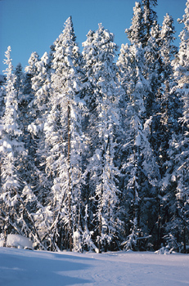  The boreal forest. |  | _________________ is the average weather of a region throughout the year. A desert, for example, has a _________________ climate even though it may rain on rare occasions. Climate is usually defined by looking at average _________________ and average _________________.  There are several things that affect climate. The most important is _________________, which is the solar energy reaching an area of the Earth’s surface. On average, regions near the _________________ receive much more sunlight than regions near the _________________.
Another fact that influences climate greatly is large bodies of _________________. Regions near oceans and large lakes tend to have cooler summers and warmer winters than regions inland. Ocean _________________ can also greatly affect climate as they carry large masses of warm or cold water around the globe. _________________ ranges also influence climate. On the windward side of mountains, moist air is forced up and cools, causing the moisture to _________________ and fall as precipitation. The air that passes over the mountain to the leeward side is now dry and this region receives very little precipitation. This dry region on the leeward side of a mountain is called a _________________.

